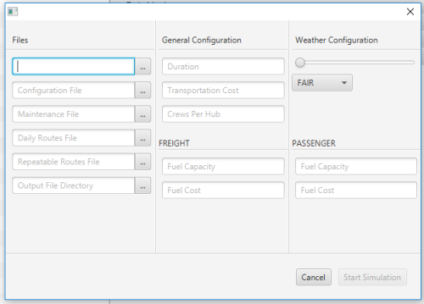

See Nbr 2-5. User can add files to the UI that would then be processed through the C++ code behind the scenes. Provided screenshots show that the only thing that was blocking us from having this to be completed was the tie in between the UI and backend. Above screenshot is the frontend view.

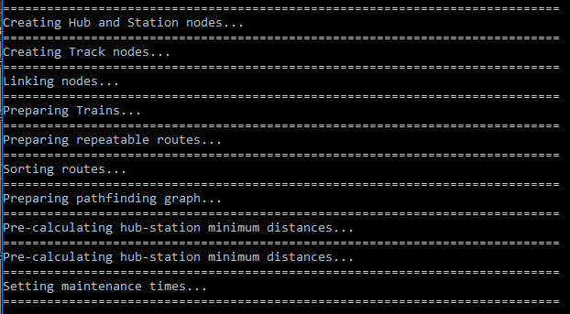

See Nbr 2-5. User can add files to the UI that would then be processed through the C++ code behind the scenes. Provided screenshots show that the only thing that was blocking us from having this to be completed was the tie in between the UI and backend. Above screenshot is the backend view notifying the user that files are actually being processed

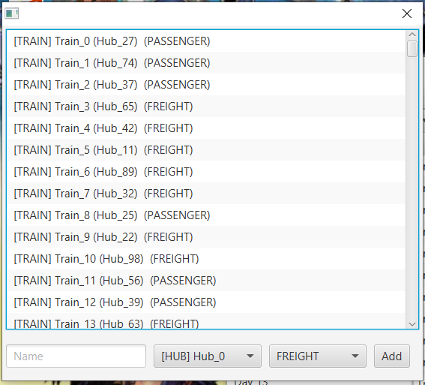

See Nbr 1. User can edit Trains in this view.

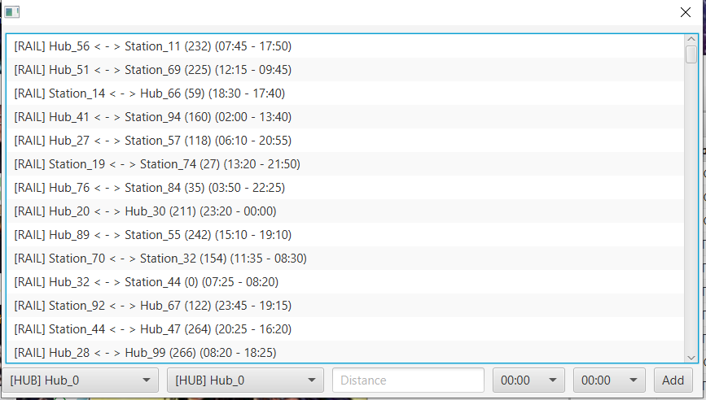

See Nbr 1. User can edit Railways in this view.

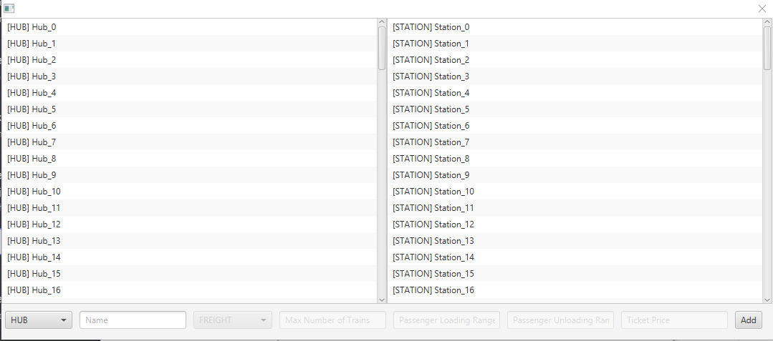

See Nbr1. User can edit Hub and Stations in this view.

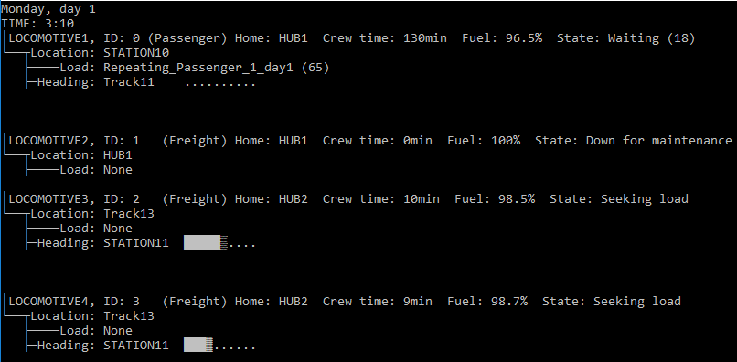

See Nbr 6. This is showing trains running in the backend during a day of the simulation run.

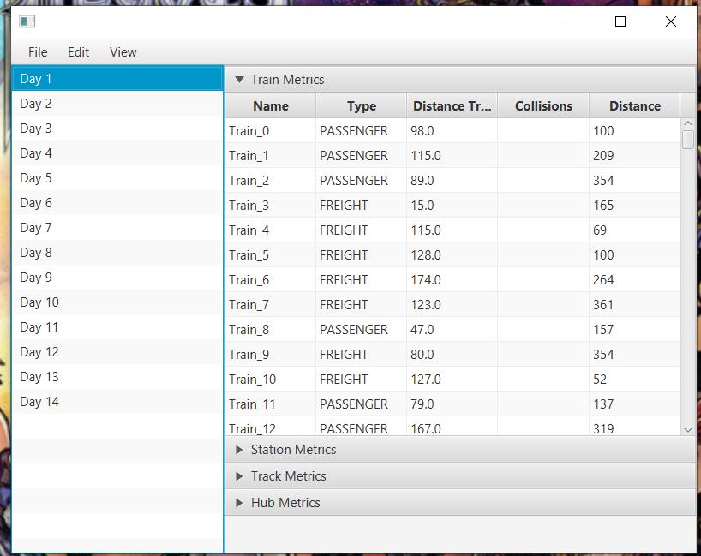

See Nbr 6. This is showing the data that was collected from our dummy data in the UI perspective.

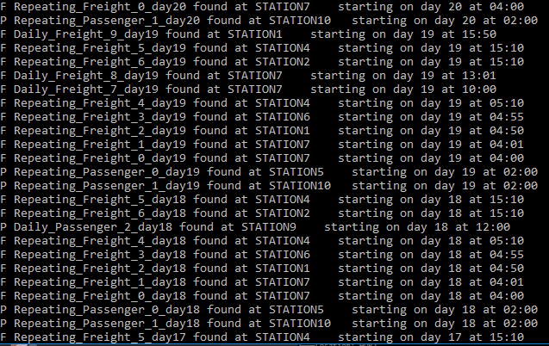

See Nbr 7. This view is the backend view that is processing the set schedules to record traffic in and end user perspective.



See Nbr 8. User can create a simulation run after entering provided amounts in the UI.

See Nbr 12. There is a UI that is currently implemented for weather severity to be updated and change.



See Nbr 13. This is the backend that shows the amount of fuel consumption during the simulation run.



See Nbr 14. User can compare between different days by clicking on the selected day in the left pane and the data would then be updated in the right pane according to user selection.

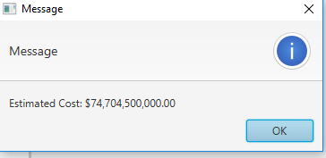

See Nbr 15. This is showing a dialog to the user that notifies them the estimated cost for running their current simulation. Since it is not linked to the backend this is not an accurate amount.

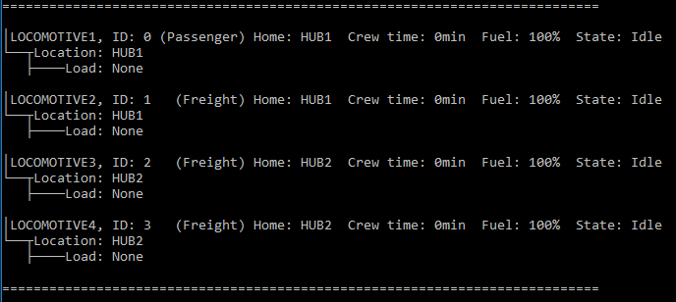

See Nbr 16. This is showing the initial movement along the tracks. Trains that are processed through the daily and repeating schedules would have priority if they need to use the track first.